NETWORK EVIDENCE ACQUISITION (PCAP), SHA-256 HASHING, AND BLOCKCHAIN SIMULATION

Assignment: Network Evidence Acquisition, SHA-256 Hashing, and Blockchain Simulation


Student Identity
Name: SAIF ALI MOHSEN DAHSHAL
NIM: 23040700108
Course: Blockchain

UNIVERSITAS MUHAMMADIYAH JAKARTA
FAKULTAS TEKNIK
2026
1. Introduction
Digital evidence integrity is one of the central challenges in network
forensics. When a network capture is collected during an investigation,
it must remain provably unchanged from the moment of acquisition to the
moment it is presented as evidence. A single stored hash value is not
enough on its own, since the hash record itself could be edited.

This project addresses that problem by combining SHA-256 hashing with a
custom-built blockchain. Every PCAP evidence file is fingerprinted with
SHA-256, and that fingerprint is sealed inside a block that is
cryptographically linked to the block before it. Because each block
encodes the previous block's hash, any change anywhere in the chain
becomes detectable through validation.
2. Objectives
- Acquire five network evidence files in PCAP format with varying packet counts.
- Calculate the SHA-256 hash of each evidence file.
- Design and implement a simple blockchain to store evidence metadata.
- Implement a validation function to verify blockchain integrity.
- Build a Merkle Tree to aggregate all evidence hashes into a single root value.
- Demonstrate tampering detection through a controlled evidence modification test.

3. Network Evidence Acquisition
Instead of capturing live traffic with Wireshark, the PCAP files were
generated programmatically using Python's built-in struct module. This
approach builds a valid libpcap file (24-byte global header, magic
number 0xA1B2C3D4, followed by 16-byte per-packet headers and raw
Ethernet/IPv4/TCP frames) without depending on Scapy or any capture
driver, making the project fully reproducible on any machine with
plain Python.
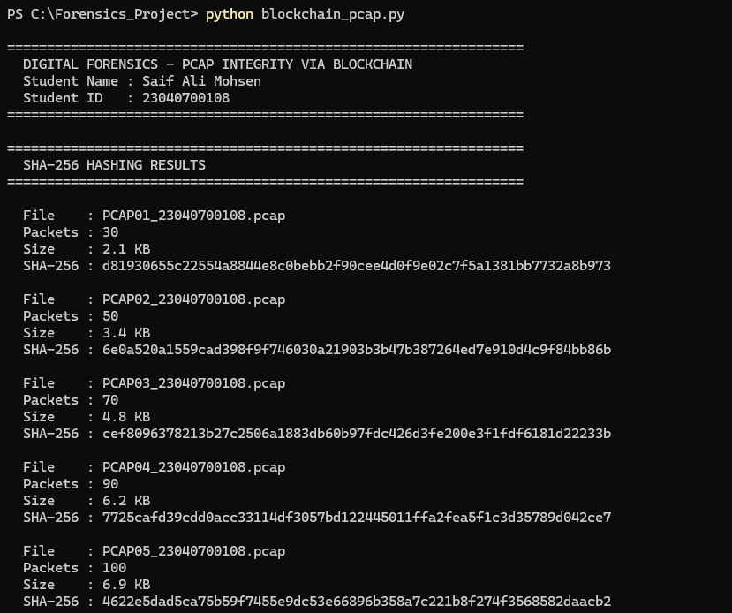
Each file contains a different number of packets to simulate different network traffic scenarios.
4. SHA-256 Hash Calculation
Each file is read in 64 KB chunks and passed into Python's
hashlib.sha256() to produce a 256-bit fingerprint. SHA-256 was chosen
because it is collision-resistant and exhibits the avalanche effect:
changing even a single bit of input produces a completely different,
unrelated output. This property is what makes tampering detectable
later in the validation step.
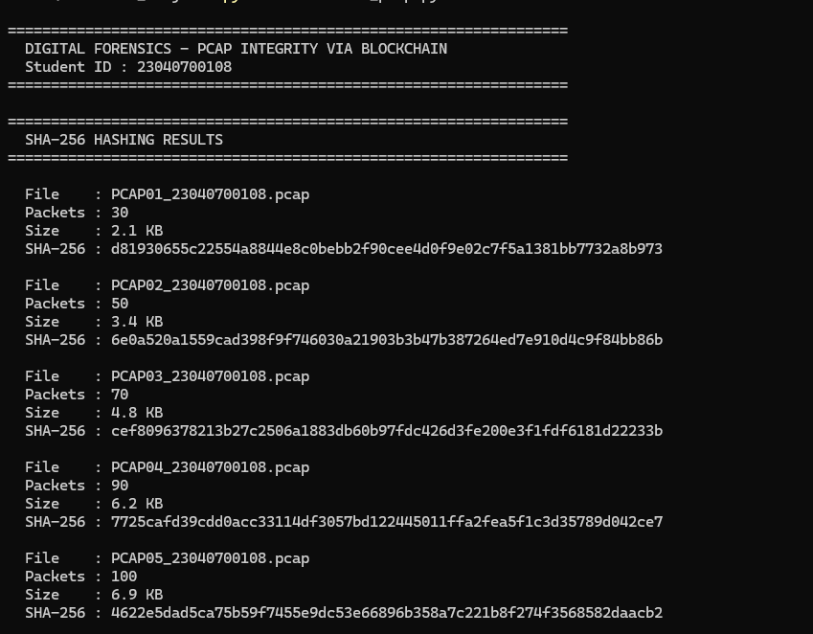
5. Blockchain Structure
The chain consists of one fixed Genesis Block followed by five Evidence
Blocks — one per PCAP file. Each block stores: index, timestamp,
evidence file name, packet count, evidence SHA-256 hash, previous block
hash, and its own block hash.
The block hash is computed by serializing all block fields (except the
block hash itself) into a sorted JSON string and hashing that string
with SHA-256. Because the previous block's hash is one of the inputs,
every block is cryptographically chained to the one before it.

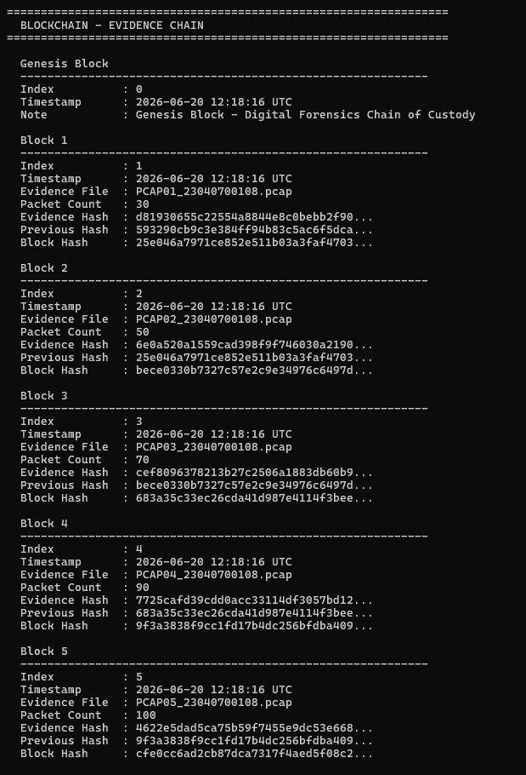

8. Merkle Tree Implementation
A Merkle Tree was implemented using the SHA-256 hashes of all evidence files.
Process:
- SHA-256 hashes are used as leaf nodes.
- Adjacent hashes are combined.
- New parent hashes are calculated.
- The process repeats until a single hash remains.
The final hash is called the Merkle Root.
Benefits:
- Efficient integrity verification.
- Reduced verification complexity.
- Commonly used in modern blockchain systems.
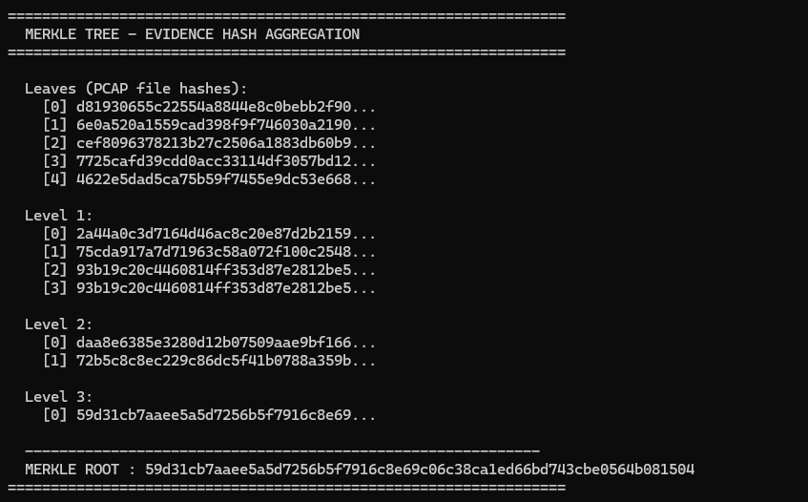
7. Blockchain Validation Mechanism
The validate_chain() function checks two conditions for every block:

1. Linkage check — the block's stored previous_hash must equal the
actual block_hash of the preceding block.
2. Integrity check — the block's stored block_hash must equal a fresh
recomputation of that hash from the block's current fields.
If both conditions hold for every block, the result is
"Blockchain Validation : VALID". If either check fails for any block,
the result becomes "Blockchain Validation : INVALID".

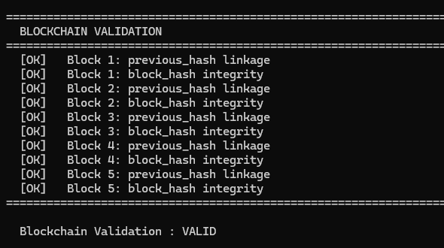
8. Tampering Simulation
A manual tampering test was performed.
Procedure:
- Blockchain was created and validated.
- One PCAP evidence file was manually modified.
- SHA-256 hash was recalculated.
- Blockchain validation was executed again.
Result:
Original evidence hash and modified evidence hash became different.
The blockchain successfully detected the modification and changed the validation status from VALID to INVALID.
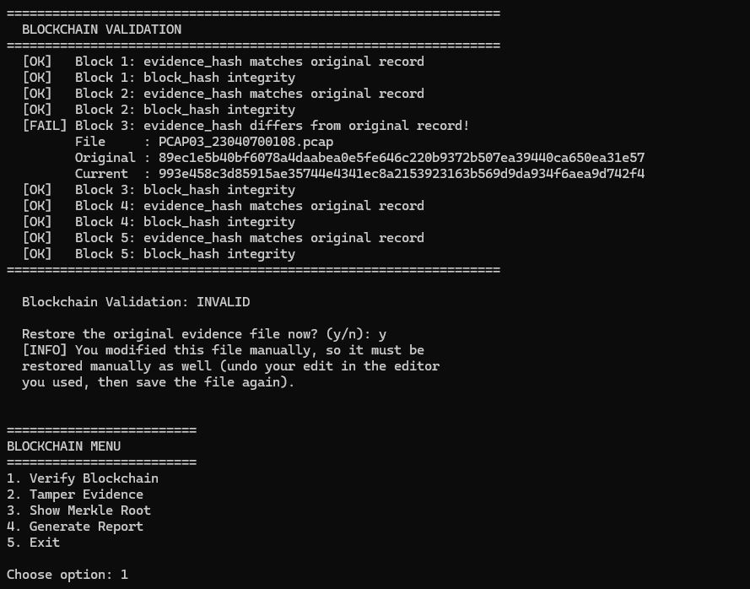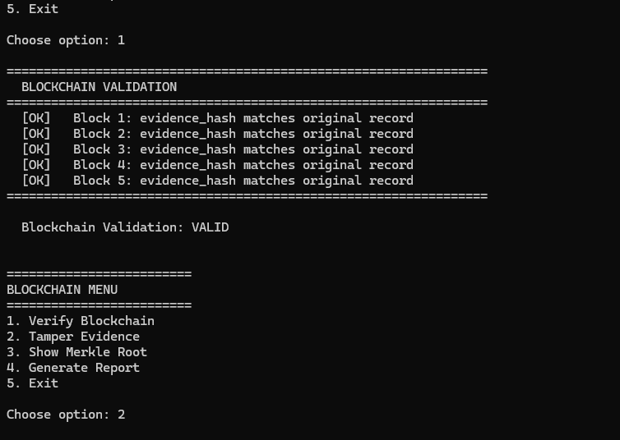
9. Results and Discussion
Before any tampering, running the blockchain validation against the
original five PCAP files produced the following result:
- Blockchain Status: VALID
- All five evidence hashes matched their baseline values exactly.
- All block hashes were correctly recomputed and verified.
- The Previous Hash field of every block correctly pointed to the
Block Hash of the block before it.
- The Merkle Root was successfully computed from all five evidence
hashes, giving a single aggregated fingerprint for the entire
evidence set.

To test the system under tampering, a single byte was modified in
PCAP01 - once using the program's built-in automatic mode, and once
by manually editing the file in a hex editor outside the program, to
confirm the detection works regardless of how the file is changed.
In both cases, the result was the same:

- The SHA-256 hash recomputed from the file no longer matched the
hash stored in the blockchain.
- The validation function flagged the corresponding evidence block
with a "evidence_hash differs from original record" error.
- The overall blockchain status changed from VALID to INVALID.
- After the file was restored to its original state, re-running the
validation correctly returned to VALID again.

This last point was particularly important: it confirms that the
validation check is genuinely dynamic and re-reads the actual file
from disk every time, rather than relying on a cached result from
when the program first started. A tool that only checks data held in
memory would have kept reporting VALID even after the file was
tampered with, which would defeat the entire purpose of the system.

The experiment demonstrates that combining SHA-256 hashing with a
linked blockchain structure can reliably preserve digital evidence
integrity and support forensic investigations, catching even a
single-byte modification regardless of where in the evidence set it
occurs.

10. Conclusion
This project successfully implemented:

- Network evidence acquisition using programmatically generated PCAP
files.
- SHA-256 hashing for digital evidence identification.
- A simple blockchain structure with a Genesis Block and five
Evidence Blocks.
- A blockchain validation mechanism that re-reads evidence files from
disk and checks them against a permanently stored baseline.
- A Merkle Tree that aggregates all evidence hashes into a single
root value.
- Both automatic and manual tampering detection, including a
file-selection feature that allows any of the five evidence files
to be checked individually.

The results show that blockchain technology can significantly
improve the integrity, traceability, and chain of custody of digital
forensic evidence. By combining SHA-256 hashing with a chained block
structure and a persistent baseline record, investigators can detect
unauthorized modifications - whether automated or manually
introduced - and maintain trustworthy evidence records throughout
the forensic process.
References

Nakamoto, S. (2008). Bitcoin: A Peer-to-Peer Electronic Cash System.

Stallings, W. Cryptography and Network Security.

NIST FIPS 180-4: Secure Hash Standard (SHA-256).

Python Software Foundation. Python 3 hashlib and struct documentation.

